[**DIGITAL SIGNAL & IMAGE PROCESSING LAB**](https://github.com/Amey-Thakur/DIGITAL-SIGNAL-AND-IMAGE-PROCESSING-AND-DIGITAL-SIGNAL-AND-IMAGE-PROCESSING-LAB)

[**EXPERIMENT -**](https://github.com/Amey-Thakur/DIGITAL-SIGNAL-AND-IMAGE-PROCESSING-LAB) **10**

**PART B**

(PART B: TO BE COMPLETED BY STUDENTS)

***(Students must submit the soft copy as per the following segments within two hours of the practical. The soft copy must be uploaded on the Blackboard or emailed to the concerned lab in charge faculties at the end of the practical in case there is no Blackboard access available)***

| **Roll No. 50** | **Name: AMEY THAKUR** |
| --- | --- |
| **Class: COMPS-BE-B-50** | **Batch: B3** |
| **Date of Experiment: 06/10/2021** | **Date of Submission: 06/10/2021** |
| **Grade :** |  |

**A.1 Aim:**

Write a program to Implement Edge Detection using Sobel and Prewitt Masks.

**B.1 Software Code written by a student:**

***(Paste your code completed during the 2 hours of practice in the lab here)***

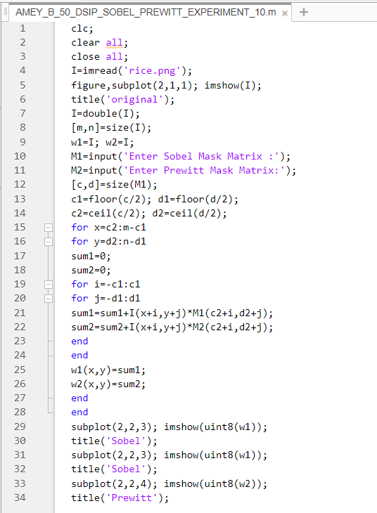

**B.2 Input and Output:**

* Horizontal

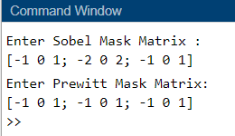

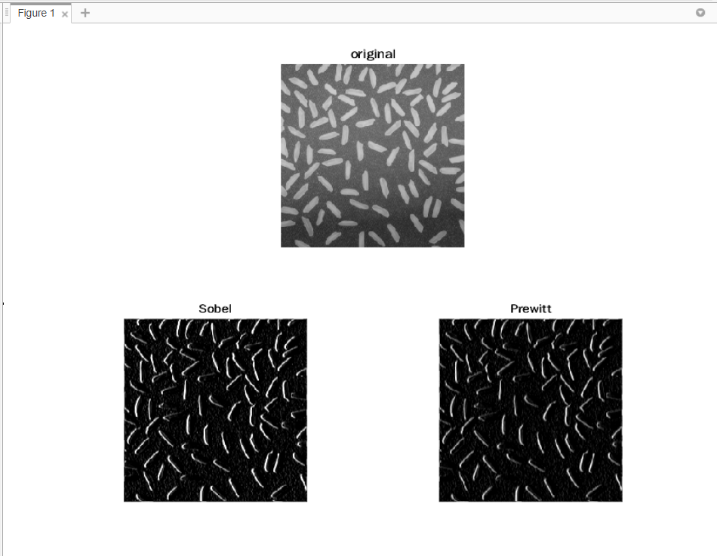

* Vertical

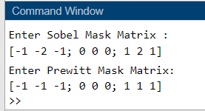

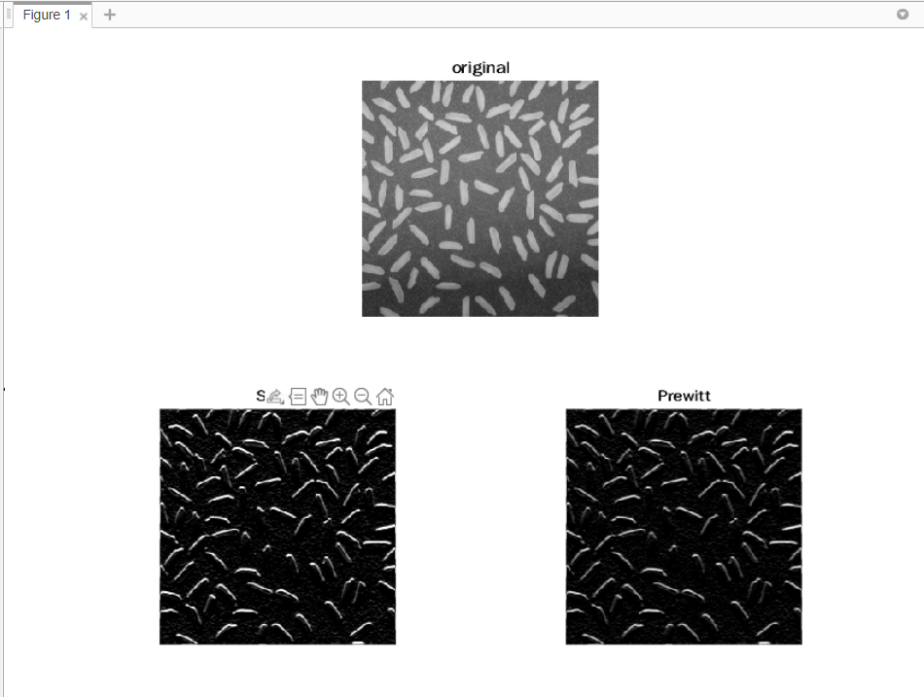

**B.3 Observations and learning:**

***(Students are expected to comment on the output obtained with clear observations and learning for each task/ subpart assigned)***

After the successful completion of this experiment, we are able to Implement Edge detection techniques using first-order derivative filters.

**B.4 Conclusion:**

***(Students must write the conclusion as per the attainment of individual outcome listed above and learning/observation noted in section B.3)***

We can write a program to Implement Edge Detection using Sobel and Prewitt Masks.

**B.5 Question of Curiosity:**

***(To be answered by student based on the practical performed and learning/observations)***

1. What are Derivatives?

Ans:

Derivative filters provide a quantitative measurement for the rate of change in pixel brightness information present in a digital image.

1. Which Edge Detection Method is effective?

Ans:

Canny edge detection is the most commonly used, highly effective and complex Edge Detection Method compared to many other methods. It is a multi-stage algorithm used to detect/identify a wide range of edges.